**Coversheet**

**The Coversheet has to contain the following:**

* **Heading “Electrical System Form FSAE-E 2015”**
* **University and Team Name**
* **Car number**
* **Main Team Contact for ESF related questions**

Feel free to add team logo, car picture, and the like.

**Requirements (delete this section after you have read and understood it):**

Read the document “How to pass ESF&FMEA” which is available at <http://www.formulastudent.de/uploads/media/FSE2011_How_to_pass_ESF_FMEA_01.pdf>

Maximum number of pages for the complete ESF is 100 pages!

Links to video or audio data are prohibited.

If you did not fill out the tables or if you changed the format of the ESF Template, you will fail by default.

Every single part/heading of the ESF Template must be filled with content. If the respective part is not relevant for your concept, describe shortly why not.

The table of contents must be hyperlinked.

The generated PDF must contain hyperlinked bookmarks (an example can be found in the FSAE Electric 2015 rules for example).

Use internal reference links. For example when describing wiring and mentioning a figure in the text then link it to the figure.

Do not just copy all of your datasheets in the appendix, e.g. we do not need to know what you have to do to program your motor controller; we do not need the whole user manuals of microcontrollers to review your ESF, etc. Similarly, do not just paste only a link to the entire data sheet. We should not need an internet connection to obtain the information necessary to review your ESF.

Single pages/figures/tables extracted from the complete datasheet showing the important parameters, figures, etc. are usually sufficient, but the source/link to the complete datasheet has to be provided. If the datasheet describes more than one type, clearly mark in the datasheet to which type you are referring / which type you plan to use.

Datasheets should only be used as a reference. Please cover the important data in your text by using tables, figures, etc.

If you refer to parts of a data sheet, then you need to provide an internal document links from the text to the respective datasheet and another internal document link back from the datasheet to the text section.  
For example a link in the motor controller section “The datasheet can be found here (clickable)” and a link above the motor controller datasheet in the appendix “The section covering the motor controller can be found here (clickable)”.

If you are unsure with respect to feedback of the reviewer, do not hesitate to write an e-mail and ask.

Parts of the ESF which are changed because of reviewer’s feedback have to be marked in red.

Following these guidelines will guarantee a swift review process.

Table of Contents

Table of Contents iii

I List of Figures vii

II List of Tables viii

III List of Abbreviations ix

1 System Overview 2

2 Electrical Systems 4

2.1 Shutdown Circuit 4

2.1.1 Description/concept 4

2.1.2 Wiring / additional circuitry 4

2.1.3 Position in car 5

2.2 IMD 6

2.2.1 Description (type, operation parameters) 6

2.2.2 Wiring/cables/connectors/ 7

2.2.3 Position in car 7

2.3 Inertia Switch 7

2.3.1 Description (type, operation parameters) 7

2.3.2 Wiring/cables/connectors/ 8

2.3.3 Position in car 8

2.4 Brake Plausibility Device 9

2.4.1 Description/additional circuitry 9

2.4.2 Wiring 9

2.4.3 Position in car/mechanical fastening/mechanical connection 9

2.5 Reset / Latching for IMD and BMS 9

2.5.1 Description/circuitry 9

2.5.2 Wiring/cables/connectors 10

2.5.3 Position in car 10

2.6 Shutdown System Interlocks 10

2.6.1 Description/circuitry 10

2.6.2 Wiring/cables/connectors 10

2.6.3 Position in car 10

2.7 Tractive system active light 10

2.7.1 Description/circuitry 10

2.7.2 Wiring/cables/connectors 11

2.7.3 Position in car 12

2.8 Measurement points 12

2.8.1 Description 12

2.8.2 Wiring, connectors, cables 12

2.8.3 Position in car 12

2.9 Pre-Charge circuitry 13

2.9.1 Description 13

2.9.2 Wiring, cables, current calculations, connectors 13

2.9.3 Position in car 14

2.10 Discharge circuitry 14

2.10.1 Description 14

2.10.2 Wiring, cables, current calculations, connectors 14

2.10.3 Position in car 15

2.11 HV Disconnect (HVD) 15

2.11.1 Description 15

2.11.2 Wiring, cables, current calculations, connectors 15

2.11.3 Position in car 15

2.12 Ready-To-Drive-Sound (RTDS) 15

2.12.1 Description 15

2.12.2 Wiring, cables, current calculations, connectors 15

2.12.3 Position in car 15

3 Accumulator 16

3.1 Accumulator pack 1 16

3.1.1 Overview/description/parameters 16

3.1.2 Cell description 16

3.1.3 Cell configuration 17

3.1.4 Cell temperature monitoring 17

3.1.5 Battery management system 17

3.1.6 Accumulator indicator 18

3.1.7 Wiring, cables, current calculations, connectors 18

3.1.8 Accumulator insulation relays 18

3.1.9 Fusing 19

3.1.10 Charging 20

3.1.11 Mechanical Configuration/materials 21

3.1.12 Position in car 21

3.2 Accumulator pack 2 21

4 Energy meter mounting 22

4.1 Description 22

4.2 Wiring, cables, current calculations, connectors 22

4.3 Position in car 22

5 Motor controller 23

5.1 Motor controller 1 23

5.1.1 Description, type, operation parameters 23

5.1.2 Wiring, cables, current calculations, connectors 23

5.1.3 Position in car 24

5.2 Motor controller 2 24

6 Motors 25

6.1 Motor 1 25

6.1.1 Description, type, operating parameters 25

6.1.2 Wiring, cables, current calculations, connectors 25

6.1.3 Position in car 26

6.2 Motor 2 26

7 Torque encoder 27

7.1 Description/additional circuitry 27

7.2 Torque Encoder Plausibility Check 27

7.3 Wiring 27

7.4 Position in car/mechanical fastening/mechanical connection 27

8 Additional LV-parts interfering with the tractive system 28

8.1 LV part 1 28

8.1.1 Description 28

8.1.2 Wiring, cables, 28

8.1.3 Position in car 28

8.2 LV part 2 28

9 Overall Grounding Concept 29

9.1 Description of the Grounding Concept 29

9.2 Grounding Measurements 29

10 Firewall(s) 30

10.1 Firewall 1 30

10.1.1 Description/materials 30

10.1.2 Position in car 30

10.2 Firewall 2 30

11 Appendix 31

# List of Figures

Figure 1‑1: Block diagram of the tractive system 2

Figure 1‑2: Block diagram of the controls/GLV system 2

Figure 2‑1: Schematics of shutdown circuit 5

Figure 2‑2: Shutdown Circuit location 6

# List of Tables

Table 1.1 General parameters 3

Table 2.1 List of switches in the shutdown circuit 4

Table 2.2 Wiring – Shutdown circuit 5

Table 2.3 Parameters of the IMD 7

Table 2.4 Parameters of the Inertia Switch 8

Table 2.5 Torque encoder data 9

Table 2.6 Parameters of the TSAL 11

Table 2.7 General data of the pre-charge resistor 13

Table 2.8 General data of the pre-charge relay 13

Table 2.9 General data of the discharge circuit 14

Table 3.1 Main accumulator parameters 16

Table 3.2 Main cell specification 17

Table 3.3 Wire data of company A, 0.205 mm² 18

Table 3.4 Basic AIR data 19

Table 3.5 Basic fuse data 19

Table 3.6 Fuse Protection Table 20

Table 3.7 General charger data 21

Table 5.1 General motor controller data 23

Table 5.2 Wire data of company A, 0.205 mm² 24

Table 6.1 General motor data 25

Table 7.1 Torque encoder data 27

Has to be hyperlinked!

# List of Abbreviations

**A:** Amps

**AIR:** Accumulator Isolation Relays

**AMS:** Accumulator Management System

**ATF:** Automatic Transmission Fluid

**AWG:** American Wire Gauge

**BMS:** Battery Management System

**CAN:** Controller Area Network

**DC:** Direct Current

**DCP:** Direct Current Pulse

**GLVS:** Grounded Low Voltage System

**HT:** High Torque

**HV:** High Voltage

**HVD:** High Voltage Disconnect

**IMD:** Insulation Monitoring Device

**RTDS:** Ready-To-Drive-Sound

**SST:** Speed Start Measurement

**TSAL:** Tractive System Active Light

**TSMP:** Tractive System Measuring Points

**TSMS:** Tractive System Master Switch

**VCU:** Vehicle Control Unit

**VDC:** Voltage Direct Current

# System Overview

The electrical system is divided into two sub-systems. The low voltage system is 12V DC, the high voltage is 196 V max. The goal of the system is to keep things simple, reliable, and safe. The selection of using proven hardware and components was used instead of recreating components whenever possible. High-level diagram of the tractive system is shown in Figure 1‑1, block diagram of individual subsystems is shown in Figure 1‑2. Basic information about the car can be found in Table 1.1.

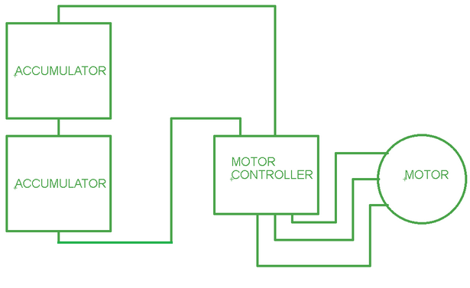

Figure 1‑1: Block diagram of the tractive system

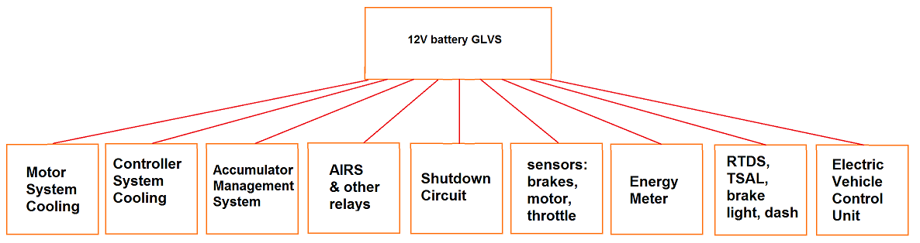

Figure 1‑2: Block diagram of the controls/GLV system

|  |  |
| --- | --- |
| Maximum Tractive-system voltage: | 196 VDC |
| Nominal Tractive-system voltage: | 180 VDC |
| Control-system voltage: | 12 VDC |
| Accumulator configuration: | 48s2p |
| Max voltage per container | 98 VDC |
| Total Accumulator capacity: | 35Ah |
| Motor type: | Permanent magnet AC motor |
| Number of motors: | 1 |
| Maximum combined motor power in kW | 50 kW (68 hp) |

Table 1.1 General parameters

# Electrical Systems

## Shutdown Circuit

### Description/concept

The shutdown circuit contains the safety circuits listed in Table 2.1. Everything is in series, except the AIR’s are in parallel with each other. If circuit is opened by the AMS or IMD, the tractive system is disabled until being manually reset by a person directly at the car which is not the driver. The driver cannot reactivate the tractive system, they can’t physically reach the reset buttons in the rear of the car. No remote reset is installed.

The two master switches will electrically turn off the 12V supply, and open the AIR’s when switched “off”. For the brake over travel switch, there is a rod attached to a toggle switch, which pulls open a contact on a relay. The tractive system does apply regenerative braking, and current flows to the high voltage battery pack. If the shutdown circuit is disconnected, both tractive system current and regenerative current is disconnected. The motor controller “bleeds” off excess energy.

|  |  |
| --- | --- |
| Part | Function |
| Main Switches ( GLVMS, TSMS) | Normally open |
| Brake over travel switch (BOTS) | Normally closed |
| Shutdown buttons (SDB) | Normally closed |
| Insulation Monitoring Device (IMD) | Normally open |
| Accumulator Management System (BMS) | Normally open |
| Inertia Switch | Normally closed |
| Interlocks - charger, AMS, IMD, BSPD, accumulators | Closed when circuits are connected |
| Brake System Plausibility Device | Normally Closed |

Table 2.1 List of switches in the shutdown circuit

### Wiring / additional circuitry

The shutdown circuit wiring is 18 AWG, stranded insulated copper wire with all components in series. All connections are made using IP 65 rated Deutsch connectors. The schematic of shutdown circuit is shown in Figure 2‑1. Table 2.2 summarizes basic info about the shutdown circuit.

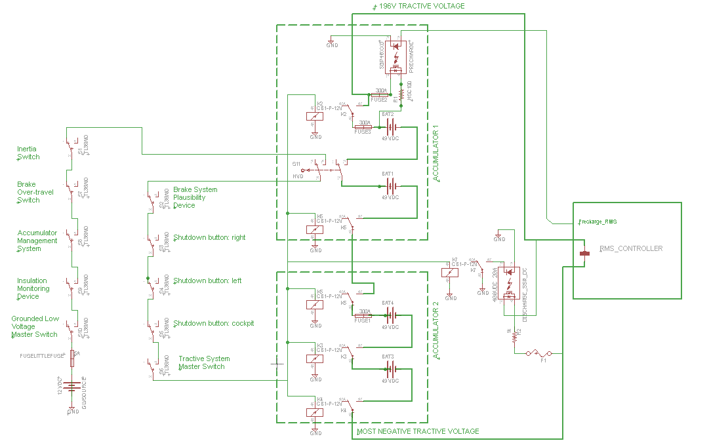

Figure 2‑1: Schematics of shutdown circuit

|  |  |
| --- | --- |
| Total Number of AIRs: | 6 |
| Current per AIR: | 0.13A |
| Additional parts consumption within the shutdown circuit: | 3A |
| Total current: | 3.78A |
| Cross sectional area of the wiring used: | 0.823 mm² (18 AWG) |

Table 2.2 Wiring – Shutdown circuit

### Position in car

The shutdown circuit is distributed throughout the car, as shown in Figure 2‑2.

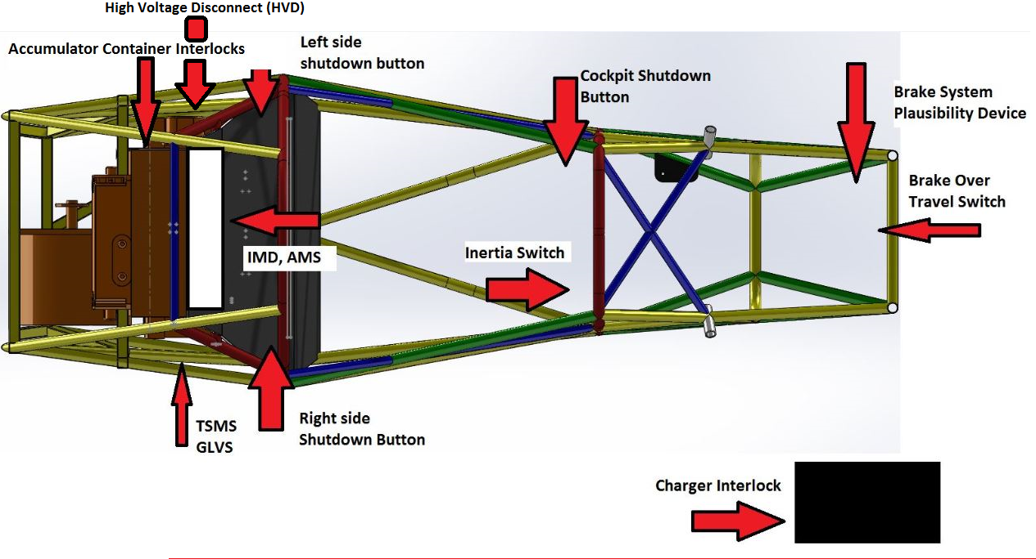

Figure 2‑2: Shutdown Circuit location

## IMD

### Description (type, operation parameters)

Describe the IMD used and use a table for the common operation parameters, like supply voltage, set point, etc. Also describe how the IMD indicator light is wired, etc.

Additionally fill out the following table replacing the values with your specification:

|  |  |
| --- | --- |
| Supply voltage range: | 10..36VDC |
| Supply voltage | 24VDC |
| Environmental temperature range: | -40..105°C |
| Selftest interval: | Always at startup, then every 20 minutes |
| High voltage range: | DC 0..1000V |
| Set response value: | 300kΩ (500Ω/Volt) |
| Max. operation current: | 500mA |
| Approximate time to shut down at 50% of the response value: | 27s |

Table 2.3 Parameters of the IMD

### Wiring/cables/connectors/

Describe wiring, show schematics, describe connectors and cables used and show useful data regarding the wiring including wire gauge/temp/voltage rating and fuses protecting the wiring.

### Position in car

Provide CAD-renderings showing the relevant parts. Mark the parts in the rendering, if necessary.

## Inertia Switch

### Description (type, operation parameters)

The inertia switch is a First Technology Resettable Crash Sensor, rated at opening the circuit at 10 g or more of deceleration.  It is in series with the shutdown circuit, and upon impact, it will activate the circuit and open the AIRs, stopping current flow. The inertia switch will remain open until the button is manually pressed, closing the circuit. Our inertia switch is mounted on close to the driver’s dash (see Figure 2‑3). It is removable to test functionality.

|  |  |
| --- | --- |
| Inertia Switch type: | First Technology resettable crash sensor |
| Supply voltage range: | 10..36VDC |
| Supply voltage: | 12VDC |
| Environmental temperature range: | -40..105°C |
| Max. operation current: | 10A |
| Trigger characteristics: | 10g for 50ms / 16g for 15ms |

Table 2.4 Parameters of the Inertia Switch

### Wiring/cables/connectors/

The wiring used for the inertia switch is stranded 18 AWG wire. The connectors is IP65 rated Deutsch connector. It is wired in series with the shutdown circuit.

### Position in car

Mounted vertically to the front roll hoop as shown in Figure 2‑3.

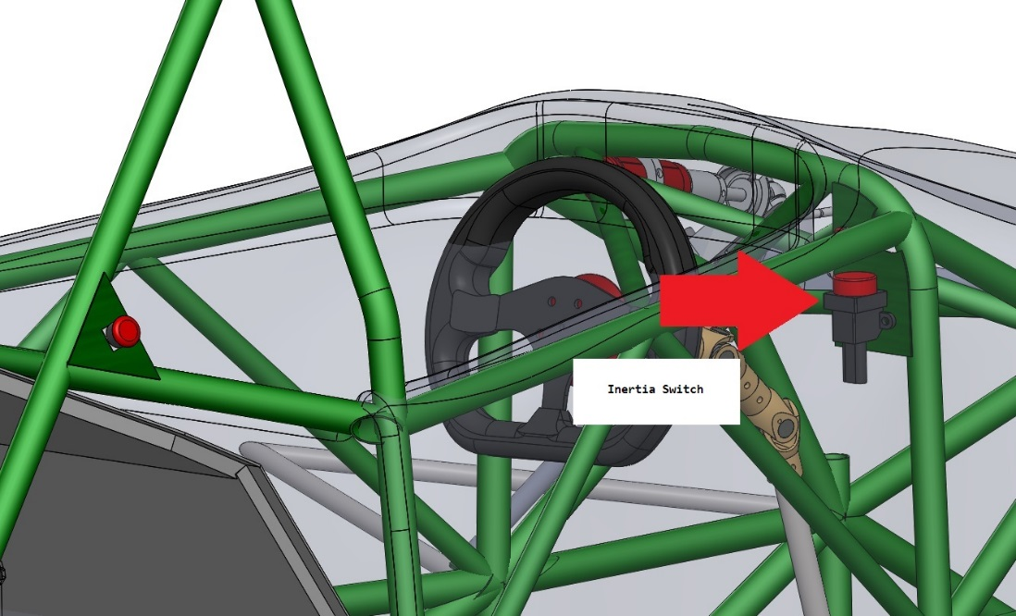

Figure 2‑3: Inertia switch location drawing

## Brake Plausibility Device

## Description/additional circuitry

Describe how your electronic hardware brake plausibility system works (this is in addition to your ECU controlled brake plausibility software), provide tables with main operation parameters, and describe additional circuitry used to check or for an implausibility. Describe how the system reacts if an implausibility or error is detected.

|  |  |
| --- | --- |
| Brake sensor used: | ABC Sensor |
| Torque encoder used: | potentiometer |
| Supply voltages: | 5V |
| Maximum supply currents: | 20mA |
| Operating temperature: | -20..180 °C |
| Output used to control AIRs: | Open a relay |

Table 2.5 Torque encoder data

## Wiring

Describe the wiring, show schematics including the circuit board, show data regarding the cables and connectors used. If not detailed in section 2.1, be sure to show how the device open the shutdown circuit.

## Position in car/mechanical fastening/mechanical connection

Provide CAD-renderings showing all relevant parts and discuss the mechanical connection of the sensors to the pedal assembly. Mark the parts in the rendering, if necessary.

## Reset / Latching for IMD and BMS

### Description/circuitry

Describe the concept and circuitry of the latching/reset system for a tripped IMD or BMS. Describe the method for resetting the IMD and BMS.

### Wiring/cables/connectors

Describe wiring, show schematics, describe connectors and cables used and show useful data regarding the wiring. If not detailed in section 2.1, be sure to show how the device opens the shutdown circuit.

### Position in car

Provide CAD-renderings showing the relevant parts. Mark the parts in the rendering, if necessary.

## Shutdown System Interlocks

### Description/circuitry

Describe the concept and circuitry of the Shutdown System Interlocks.

*Note: Interlocks are circuits used to open the shutdown circuit if a connector is disconnected or enclosure is opened. This is not the entire shutdown circuit.*

### Wiring/cables/connectors

Describe wiring, show schematics, describe connectors and cables used and show useful data regarding the wiring.

### Position in car

Provide CAD-renderings showing the relevant parts. Mark the parts in the rendering, if necessary.

## Tractive system active light

### Description/circuitry

The tractive system active light (TSAL) is LED lights, red in color, and flashes at a frequency of ~3 Hz.  It is clearly visible 360 degrees around the entire car when the tractive system is activated.  Each light is 12 lumens, bright enough to be clearly visible by a person standing 3 meters away from the TSAL.  It is the only light located anywhere near that area.  The 3 Hz frequency is created by TSAL circuitry (basically 555 timer and two transistors). The light is provided by red waterproofed LED strip, that is powered by 12V and is cut to size.

TSAL is placed in cylindrical enclosure under the main roll hoop. Inside the enclosure is also RTDS buzzer. The enclosure is 3D printed, consists of two parts that are glued together, as shown in Figure 2‑4.

|  |  |
| --- | --- |
| Supply voltage: | 12VDC |
| Max. operational current: | 700mA |
| Lamp type | LED |
| Power consumption: | 4.5 W |
| Brightness | 100 Lumen |
| Frequency: | 3.2Hz |
| Size (length x height x width): | 3” x 1.5” x 1.5” |

Table 2.6 Parameters of the TSAL

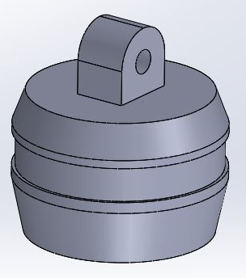

Figure 2‑4 TSAL & RTDS enclosure drawing

### Wiring/cables/connectors

HV+ lead is connected on the motor side of the main contactor, and HV- is connected on most negative lead.  When the precharge circuit has completed, and the main contactor closes, tractive system voltage is at ~196 VDC max. There is a zener diode at the HV+ input, preventing voltages < 60 V to activate circuit. LR8 high voltage linear regulator provides power to ILD74 optocoupler, which separates HV and LV. Timer 555 is powered by 12V and takes care of periodical switching of the transistors. That way we can switch larger loads necessary to power the lights.  We tested the circuit and it provides satisfactory results. The wiring diagram is shown in Figure 2‑5, the PCB layout is shown in Figure 2‑6.

Running Vout trace between Vin and Vref pins is not a concern, since all traces are covered by top layer. On top of that, we cover whole board with a layer of conformal coating to protect the PCB from corrosion, provide insulation resistance, and possible shorting.  We will be using an Acrylic Conformal Coating 419C to achieve this.The dielecric withstand voltage value is >1500V which is sufficient for our application.

TSAL has 4 LV inputs (LIGHT+, LIGHT-, GND, 12V+) and two HV inputs (HV+, HV-). TSAL PCB is inside the main contactor box, with only LIGHT+ and LIGHT- 18AWG wires coming the the TSAL enclosure under the roll hoop. This way HV leads don’t have to  be outside the contactor box, making design simpler.

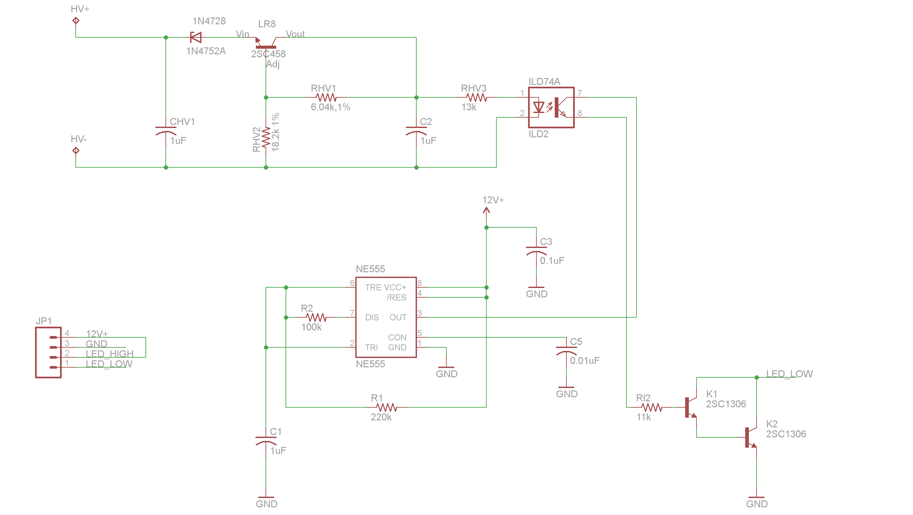

Figure 2‑5 Wiring diagram of TSAL

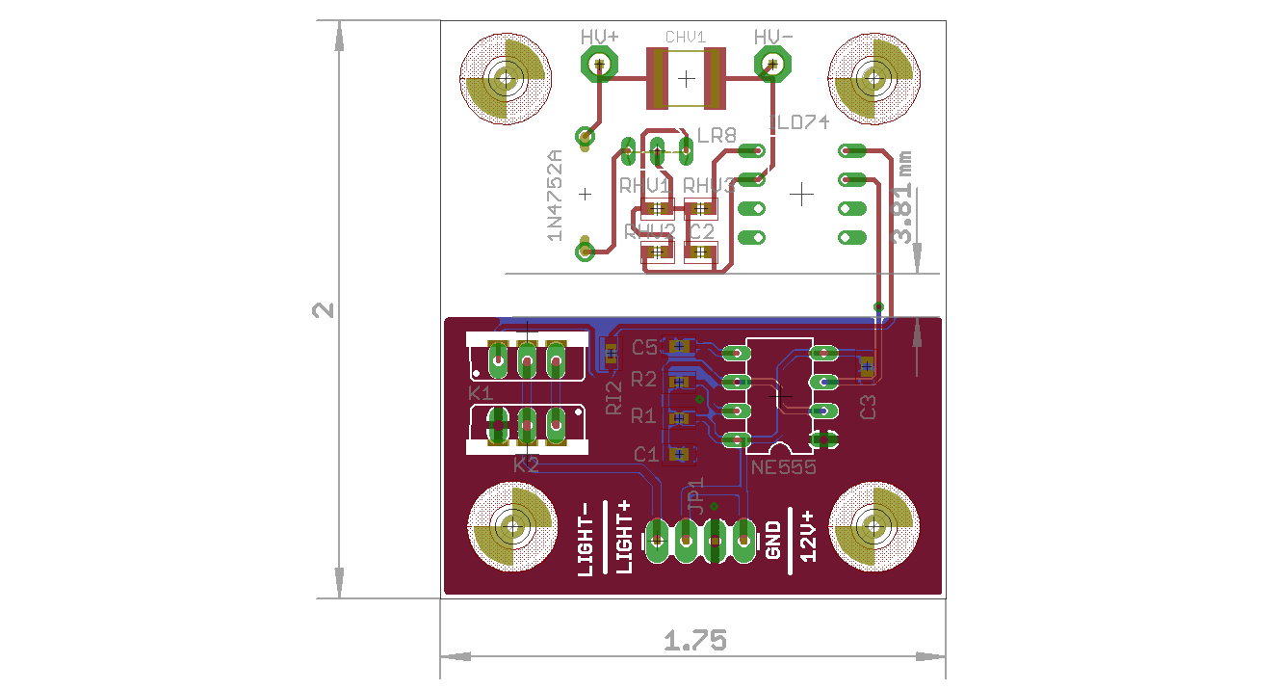

Figure 2‑6 Board Layout of TSAL (board dimensions are in inches)

### Position in car

The light is mounted on the top of the roll hoop, and is unable to contact the driver’s helmet (we measured that there is enough clearance), as shown in Figure 2‑7.

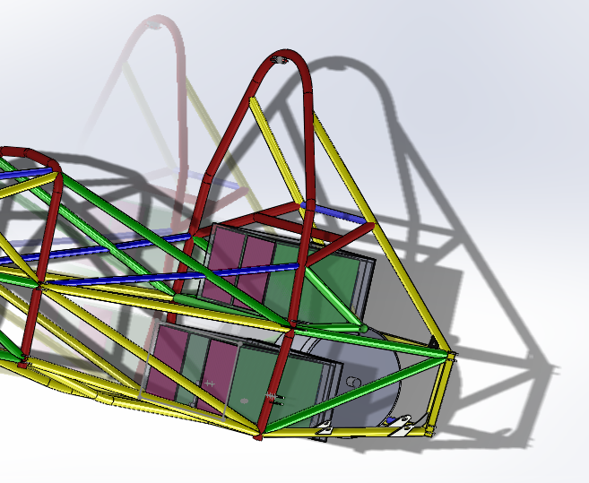

Figure 2‑7 Position of TSAL in the car, under the top of the main roll hoop

## Measurement points

### Description

Describe the housing used and how it can be accessed, etc. Describe how the measurement points protected/covered when not in use and how the electrical connections on the back of the measurement points are protected when the measurement points are being used.

### Wiring, connectors, cables

Describe wiring, show schematics, and describe connectors and cables used and show useful data regarding the wiring. Include details on the protection resistor including resistance, voltage and power rating.

### Position in car

Provide CAD-renderings showing the relevant parts. Mark the parts in the rendering, if necessary.

## Pre-Charge circuitry

### Description

Describe your concept of the pre-charge circuitry.

### Wiring, cables, current calculations, connectors

Describe wiring, show schematics, describe connectors and cables used and show useful data regarding the wiring.

* Give a plot “Percentage of Maximum Voltage” vs. time
* Give a plot Current vs. time
* For each plot, give the basic formula describing the plots

Additionally fill out the tables:

|  |  |
| --- | --- |
| Resistor Type: | ABC Resistor |
| Resistance: | 680Ω |
| Continuous power rating: | 60W |
| Overload power rating: | 200W for 30 sec |
| Voltage rating: | 1500V |
| Cross-sectional area of the wire used: | 0.205 mm² |

Table 2.7 General data of the pre-charge resistor

|  |  |
| --- | --- |
| Relay Type: | DEF Relay |
| Contact arrangment: | SPDT, SPST, SPCO, SPTT, DPST, …. |
| Continuous DC current: | 25A |
| Voltage rating | 2000VDC |
| Cross-sectional area of the wire used: | 0.205 mm² |

Table 2.8 General data of the pre-charge relay

### Position in car

Provide CAD-renderings showing all relevant parts. Mark the parts in the rendering, if necessary.

## Discharge circuitry

### Description

Describe your concept of the discharge circuitry.

### Wiring, cables, current calculations, connectors

Describe wiring, show schematics, describe connectors and cables used and show useful data regarding the wiring.

* Give a plot “Voltage” vs. time
* Give the formula describing this behavior
* Give a plot “Discharge current” vs. time
* Give the formula describing your plot

Additionally fill out the table:

|  |  |
| --- | --- |
| Resistor Type: | ABC Resistor |
| Resistance: | 680Ω |
| Continuous power rating: | 350W |
| Overload power rating: | 600W for 20 sec |
| Voltage rating: | 1500V |
| Maximum expected current: | 0.7A |
| Average current: | 0.3A |
| Cross-sectional area of the wire used: | 0.205 mm² |

Table 2.9 General data of the discharge circuit

### Position in car

Provide CAD-renderings showing all relevant parts. Mark the parts in the rendering, if necessary.

## HV Disconnect (HVD)

### Description

Describe your concept of the HVD and how it can be operated.

### Wiring, cables, current calculations, connectors

Describe wiring, show schematics, describe connectors and cables and show useful data regarding the wiring. Include information on the working voltage and current rating of the HVD.

### Position in car

Provide CAD-renderings showing all relevant parts. Mark the parts in the rendering, if necessary.

## Ready-To-Drive-Sound (RTDS)

### Description

The RTDS is a sustained 3 kHz tone emitted at 80 dBA for 2 seconds. One buzzer will be used, and will have max 75 mA current supplied by the 12V battery.  This indicates the tractive system is on, and the precharge circuit has completed, and the vehicle is ready to drive and will be propelled once the driver presses the accelerator pedal. We are using **PUI Audio AI-5025-TWT-R buzzer**.

Once the motor controller changes its state into “Ready-to-drive”, the Vehicle Control Unit (VCU) reads its state over CAN and triggers the “Forward Enable” switch on the motor controller (J1-30)  as well as RTDS circuit (using the enable pin on the buzzer).

The car can be set to Ready-to-Drive mode by applying the following steps:

1. switch on Tractive System Master Switch
2. switch on Low Voltage Master Switch
3. The motor controller will initiate precharge and if the voltage at the controller DC HV inputs is higher than 100V after 4 seconds of precharge, it will close main contactor
4. The motor controller is in standby mode now
5. Driver has to press simultaneously brake pedal and flip the FORWARD_ENABLE switch to ON set the vehicle into Ready-to-Drive mode

If any of these points are not met, the car cannot go into ready to drive mode.

### Wiring, cables, current calculations, connectors

The RTDS will be powered by the 12V grounded low voltage system, have a 75 mA maximum current, and is controlled by the VCU. The entire circuit will use 18 gauge wire. The circuit is shown in Figure 2‑8.

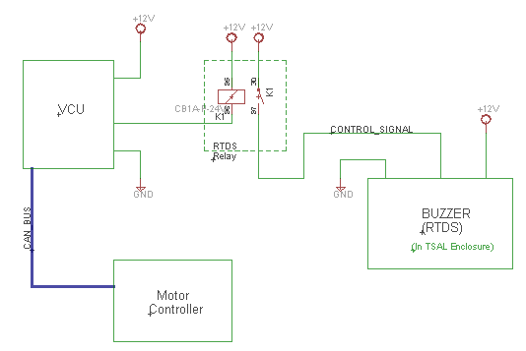

Figure 2‑8 Wiring diagram of RTDS (LV fuses not included for brevity)

### Position in car

The buzzer (which is basically the whole circuit) is placed together with TSAL in the oval enclosure under main roll hoop. That way the sound will be loud and clear. The position of the RTDS circuit is shown in Figure 2‑7.

# Accumulator

## Accumulator pack 1

### Overview/description/parameters

Describe concept of accumulator pack, provide table with main parameters like number of cells, cell stacks separated by maintenance plugs, cell configuration, resulting voltages->minimum, maximum, nominal, currents, capacity etc.

Fill out the following table:

|  |  |
| --- | --- |
| Maximum Voltage: | 550VDC |
| Nominal Voltage: | 500VDC |
| Minimum Voltage: | 300VDC |
| Maximum output current: | 405A for 10s |
| Maximum nominal current: | 250A |
| Maximum charging current: | 50A |
| Total numbers of cells: | 200 |
| Cell configuration: | 100s2p |
| Total Capacity: | 21.6 MJ |
| Number of cell stacks < 120VDC | 5 |

Table 3.1 Main accumulator parameters

### Cell description

Describe the cell type used and the chemistry, provide table with main parameters.

Fill out the following table:

|  |  |
| --- | --- |
| Cell Manufacturer and Type | Kokam XYZ |
| Cell nominal capacity: | 5.4 Ah |
| Maximum Voltage: | 4.2 V |
| Nominal Voltage: | 3.7V |
| Minimum Voltage: | 2.8V |
| Maximum output current: | 20C for 10s |
| Maximum nominal output current: | 15C |
| Maximum charging current: | 5C |
| Maximum Cell Temperature (discharging) | 65°C |
| Maximum Cell Temperature (charging) | 55°C |
| Cell chemistry: | LiFePO4 |

Table 3.2 Main cell specification

### Cell configuration

Describe cell configuration, cell interconnect, show schematics of electrical configuration and CAD of connection techniques, cover additional parts like internal cell fuses etc.

### Cell temperature monitoring

Describe how the temperature of the cells is monitored, where the temperature sensors are placed, how many cells are monitored, etc. Show schematics, cover additional parts, etc.

### Battery management system

Describe the BMS used including at least the following:

* Sense wiring protection (fusing / fusible link wire used)
* What upper and lower voltage does the BMS react at and how does it react?
* What cell temperature does the BMS react at and how does it react?
* Show tables of operation parameters
* Describe how many cells are sensed by each BMS board, the configuration of the cells, the configuration of the boards and how any comms wiring between boards is protected
* Describe how the BMS is able to open the AIRs if any error is detected
* Describe where galvanic isolation occurs between TS and GLV system connections.

### Accumulator indicator

Describe the indicator, show wiring, provide tables with operation, PCB design, etc.

### Wiring, cables, current calculations, connectors

Describe the internal wiring, show schematics, provide calculations for currents and voltages and show data regarding the cables and connectors used.

* Discuss maximum expected current, DC and AC how long will this be provided?
* Compare the maximum values to nominal currents
* Give a table for each kind of wire in your tractive-system:
* Describe your maintenance plugs, provide pictures
* Use tables like the one shown below:

|  |  |
| --- | --- |
| Wire type | Company A, |
| Continuous current rating: | 150A |
| Cross-sectional area | 0.205 mm² |
| Maximum operating voltage: | 800VDC |
| Temperature rating: | 150 °C |
| Wire connects the following components: | Cell and BMS |

Table 3.3 Wire data of company A, 0.205 mm²

### Accumulator insulation relays

Describe the AIRs used and their main operation parameters, use tables, etc.

Additionally fill out the following table:

|  |  |
| --- | --- |
| Relay Type: | ABC Relay |
| Contact arragment: | SPST |
| Continous DC current rating: | 100A |
| Overload DC current rating: | 200A for 10sec |
| Maximum operation voltage: | 800VDC |
| Nominal coil voltage: | 24VDC |
| Normal Load switching: | Make and break up to 300A |
| Maximum Load switching | 10 times at 1500A |

Table 3.4 Basic AIR data

### Fusing

Describe the fuses used and their main operation parameters, use tables, etc.

Additionally fill out the following table for each fuse type used:

|  |  |
| --- | --- |
| Fuse manufacturer and type: | ABC Fuse company, MNO Fuse |
| Continous current rating: | 150A |
| Maximum operating voltage | 500VDC |
| Type of fuse: | High speed |
| I2t rating: | 1500A2s at 450VDC |
| Interrupt Current (maximum current at which the fuse can interrupt the current) | 10000A |

Table 3.5 Basic fuse data

Create a table with components and wires protected by the fuse(s) and the according continuous current rating, below is an example table with some potential entries. Complete this table with information for your design and add/remove additional locations as applicable. Ensure that the rating of all of the components is greater than the rating of the fuse such that none of the other components become the fuse.

|  |  |  |  |  |
| --- | --- | --- | --- | --- |
| Location | Wire Size | Wire Ampacity | Fuse type | Fuse rating |
| Cells to AIRs | 2 AWG | XXX | MNO Fuse | XXX |
| AIR to Motor controller | 0 AWG | XXX | 2x MNO Fuse | XXX |
| AIR to TSAL | 20 AWG | XXX | EFG Fuse | XXX |
| Accumulator output connector | 2 AWG | XXX |  |  |
| Cells to BMS |  |  |  |  |

Table 3.6 Fuse Protection Table

### Charging

Describe how the accumulator will be charged. How will the charger be connected? How will the accumulator be supervised during charging? Show schematics, CAD-Renderings, etc., if needed

Additionally fill out the table:

|  |  |
| --- | --- |
| Charger Type: | ABC Charger |
| Maximum charging power: | 3kW |
| Maximum charging voltage: | 550V |
| Maximum charging current: | 20A |
| Interface with accumulator | CAN-Bus, proprietary, serial communication... |
| Input voltage: | 230 VAC |
| Input current: | 16A |

Table 3.7 General charger data

### Mechanical Configuration/materials

Describe the concept of the container, show how the cells are mounted, use CAD-Renderings, show data regarding materials used, etc.

### Position in car

Provide CAD-renderings showing the relevant parts. Mark the parts in the rendering, if necessary. Ensure that the required mechanical structure to protect the accumulator and other electrical components is clearly identified.

## Accumulator pack 2

…

If identical parts are used, just refer to the corresponding sections, don’t copy and paste.

# Energy meter mounting

## Description

Describe where the energy meter is mounted and how, etc.

## Wiring, cables, current calculations, connectors

Describe the wiring, show schematics, provide calculations for currents and voltages, and show data regarding the cables and connectors used.

## Position in car

Provide CAD-renderings showing all relevant parts. Mark the parts in the rendering, if necessary.

# Motor controller

## Motor controller 1

### Description, type, operation parameters

The motor is operated by a RMS PM100 motor controller. The motor has software onboard that varies the voltage supply to the motor based on input directly from the motor, as well as CAN messages from the vehicle control unit. Basic information is provided in Table 5.1.

Fill out the following table:

|  |  |
| --- | --- |
| Motor controller type: | RMS PM100DX Controller |
| Maximum continous power: | 105kW |
| Maximum peak power: | 122kW for 10s |
| Maximum Input voltage: | 360VDC |
| Output voltage: | 187VAC |
| Maximum continuous output current: | 300A |
| Maximum peak current: | 350A for 5s |
| Control method: | CAN, Hardware IO |
| Cooling method: | Water cooled via radiator |
| Auxiliary supply voltage: | 12VDC |

Table 5.1 General motor controller data

### Wiring, cables, current calculations, connectors

The low voltage side of the controller uses 2 AMPSEAL connectors (one 35 pin, and one 23 pin). All low voltage wires will use the same 18 AWG wire as the rest of the low voltage system, all wires will be rated to maximum tractive system voltage, at least 196V.

High voltage AC and DC wires are 2 AWG cable rated for a 600 V/ 255 A current. All 5 cables are installed to the controller as specified by the manufacturer, and bolted securely. The controller uses hex tool metal cable glands (cord grips). All tractive system conductors will be enclosed in orange, non-conductive conduit rated for at least 600V, securely fastened at each termination.

2 AWG cable is used outside of the Accumulator containers, instead of 4 AWG cable, because of the limited availability of the high voltage quick disconnects that include interlock mechanisms that can accept smaller gauge cable and still satisfy rule requirement and be watertight. Also, the high voltage AC/DC connections on the PM100 controller are designed to accept 2 AWG cable, along with the 3-phase connections on the Remy motor. Information about wiring is summarized in Table 5.2.

|  |  |
| --- | --- |
| Wire type: | Irradiated Exrad Shielded 2 AWG battery cable |
| Current rating: | 255A |
| Maximum operating voltage: | 600V |
| Temperature rating: | -70 to 150 °C |

Table 5.2 Wire data of Irradicated Exrad Shielded 2 AWG battery cable

### Position in car

It is our understanding that it is acceptable to have the motor controller protrude out of the main hoop supports because in the vertical side and rear planes the controller is still protected on all sides with 3 members, and is above the 350 mm side impact structure.

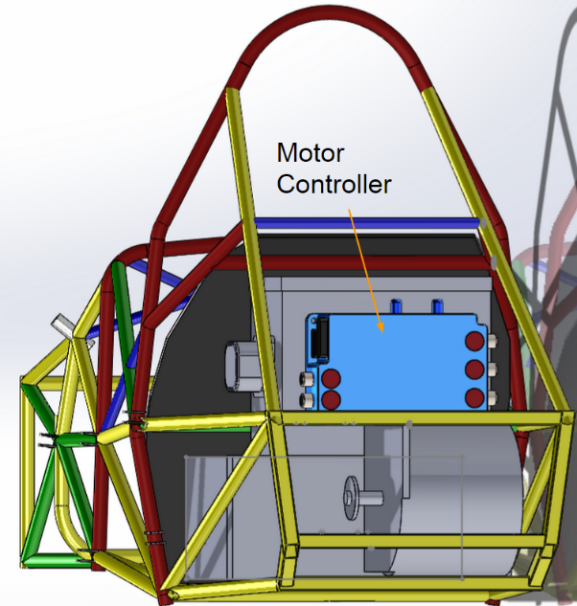 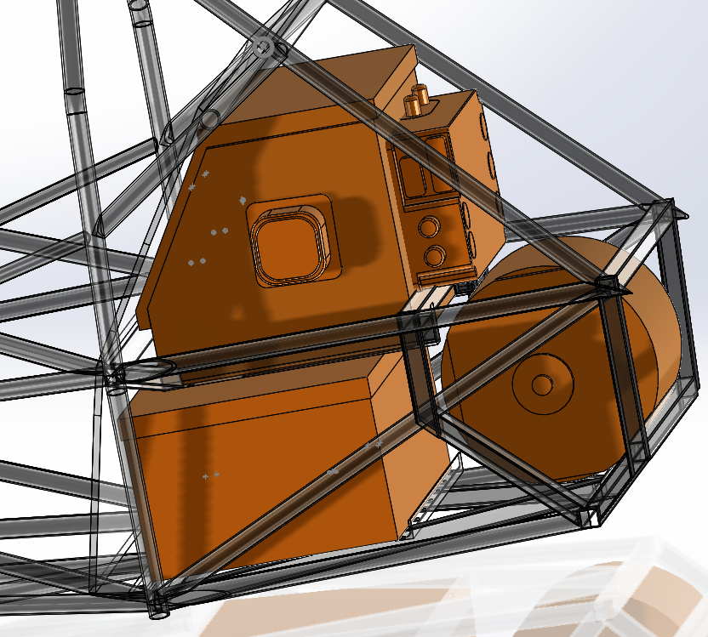

Figure 5‑1 Position of the motor controller (rear and isometric view)

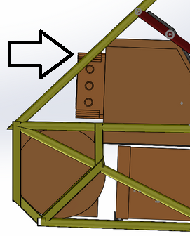

Figure 5‑2 Position of the motor controller (side view)

# Motors

## Motor 1

### Description, type, operating parameters

The Remy HVH 250 115 HT is the high torque (115mm core) version. The motor is rated for 87 kW peak power. This application runs at a reduced voltage (196V) and power rating (42kW). The motor is broken down into the following components:

1. Cartridge- The cartridge contains the bearings, rotor, stator and resolver. The cartridge is close-tolerance to ensure magnetic air gap.
2. Stator- The stator allows high current within the windings. It is 10-pole with series and parallel windings. It also contains temperature sensors to signal controller to limit power and excessive temperatures.
3. Rotor- The rotor provides magnetic performance by optimizing magnetic positioning, power density and rotational inertia.
4. Resolver- The resolver receives field coil excitation from, and returns sensor coil signals to the inverter to provide precision rotor position information for accurate synchronization of the signals supplied by the inverter.
5. Enclosure - The enclosure houses the cartridge, carries the shaft load, and supports the weight of the motor.The final motor enclosure is a 6 mm aluminum cylinder with two end plates.

Basic motor information is summarized in Table 6.1. Figure 6‑1 shows plot of motor power and torque vs RPM.

|  |  |
| --- | --- |
| Motor Manufacturer and Type: | Remy HVH 250 |
| Motor principle | permanent magnet AC |
| Maximum continuous power: | 120 kW |
| Peak power: | 160kW |
| Input voltage: | 276 VAC |
| Nominal current: | 200 A |
| Peak current: | 300 A |
| Maximum torque: | 330 Nm |
| Nominal torque: | 248 Nm |
| Cooling method: | Oil-injected |

Table 6.1 General motor data

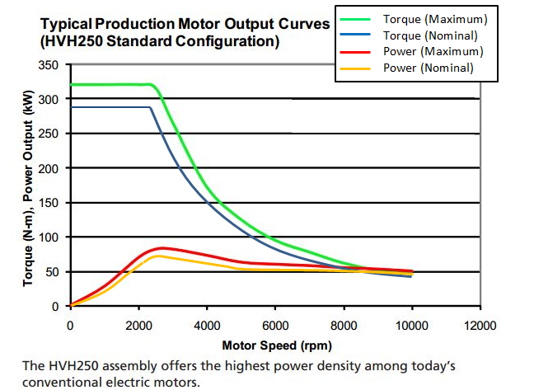

Figure 6‑1 Plot of power vs. RPM and Torque vs. RPM for Remy HVH250 motor

### Wiring, cables, current calculations, connectors

There are two connectors, one for low voltage and high voltage. The low voltage connector is a 10-pin Delphi Metri-pack 150. This is the resolver connector, and also transmits temperature data to the controller.

The high voltage is a 3 phase, 320 volt, 200 amp continuous, 300 amp peak connector. This application will require the wire to be rated at 220 amps for 196 volt use. As prescribed by the controller manufacturer, 2 AWG shielded cable is used, and the ampacity is 255A, and our tractive system is fused upstream in the accumulator containers to 70A. The line to line voltage is 196 volts, and the value is determined from the controller nominal voltage input:

$$V_{ac}=\frac{V_{DC}}{\sqrt{2}}=\frac{264}{\sqrt{2}}=196V$$

220 amps peak is determined from the power curve supplied by Remy for a 196 volt input.

The high voltage connector is a 2 AWG battery cable lug on each of the three motor phases. For this connection we choose the Molex 19221-0418 Battery Cable Lugs. The motor terminals have an OEM positive locking washer fixed on the terminals. The cables are attached to a housing with cable glands that require a wrench to remove, and the motor cables are shielded. The housing completely encloses the tractive system cables, and it is not possible to touch them with the housing in place. Orange conduit will be installed to protect the cables. The motor traction connection is shown in Figure 6‑2.

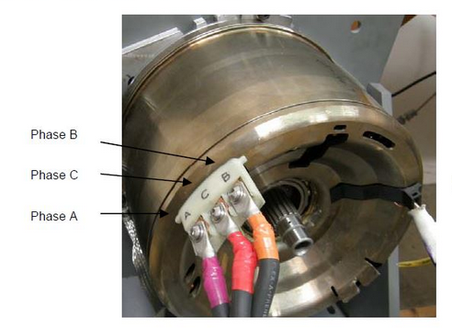

Figure 6‑2 Motor traction connection

### Position in car

The motor will be mounted at the rearmost structural section of the chassis, as shown in Figure 6‑3 and Figure 6‑4.

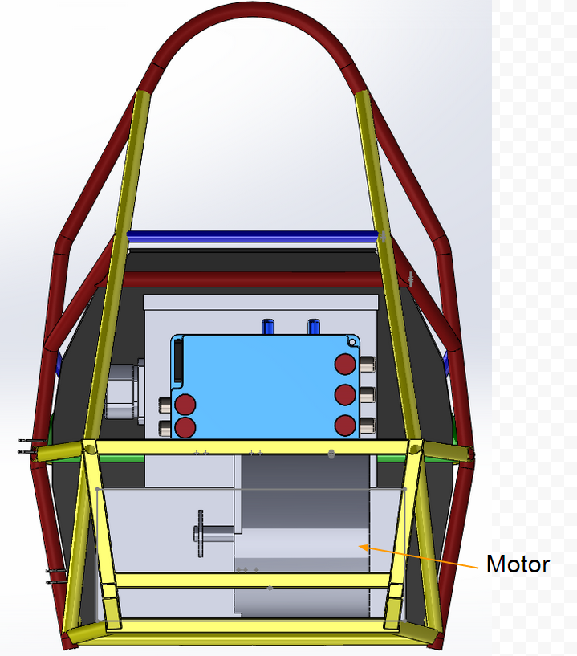

Figure 6‑3 Motor and enclosure placement (rear view)

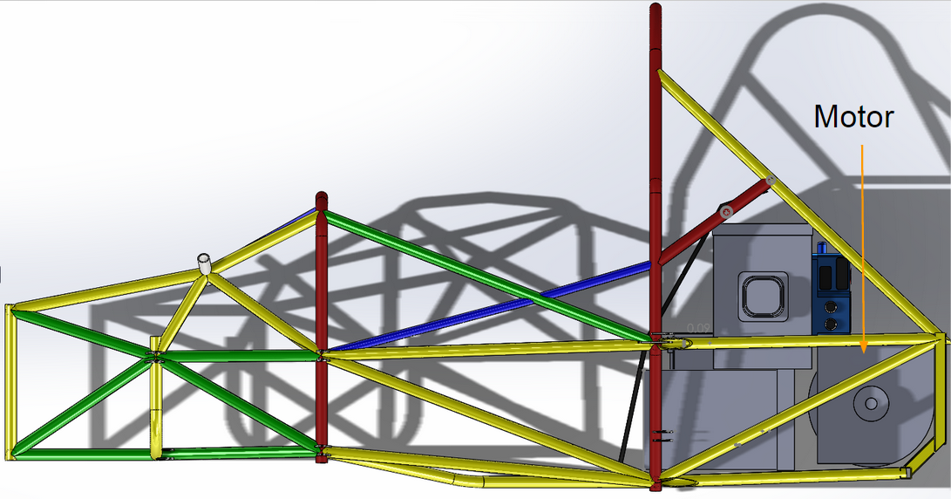

Figure 6‑4 Motor and enclosure placement (side view)

# Torque encoder

## Description/additional circuitry

The torque encoder used is originally from Toyota Prius and has two hall-effect position sensors, and produces two outputs. Basic info about the torque encoder is shown in Table 7.1., the encoder diagram and output voltage mapping is shown in Figure 7‑1. The torque encoder signal is sent to the VCU to perform plausibility check. From VCU it is sent to motor controller. The signal is not amplified (the requested torque can be only lowered) before being sent to the motor controller.

|  |  |
| --- | --- |
| Torque encoder manufacturer and type: | [Toyota Prius Throttle Pedal 78120-47050](http://www.evwest.com/catalog/product_info.php?products_id=280&osCsid=glqa9mnomt0fgrhlplo6vgps42) |
| Torque encoder principle: | Hall-Effect |
| Supply voltage: | 5 VDC |
| Maximum supply current: | 20mA |
| Operating temperature: | -40 to 85 C |
| Used output: | 0-5V |

Table 7.1 Torque encoder data

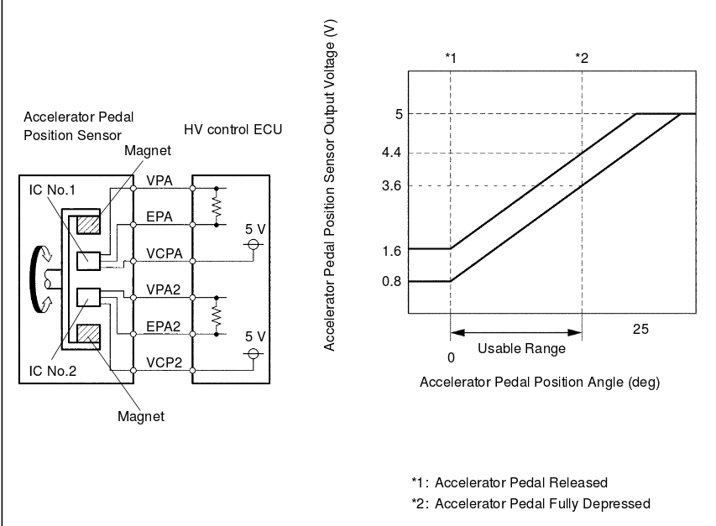

Figure 7‑1 Torque encoder functional description

## Torque Encoder Plausibility Check

The two torque encoders need to be within 10% pedal travel of each other. We know that the produced voltages are offset (see above), so first we have to map the voltages to a pedal position. If the implausibility occurs, motor controller is disabled (by opening ENABLE input to the controller) and the output voltage of the torque encoder is pulled low (0V). The encoder plausibilty checks work as following:

1. Feed both encoder outputs into analog inputs (0-5V) on VCU
2. VCU checks if the values are not below minimal threshold (1.6V and 0.8V respectively) – if so, that means the pedal is grounded, and motor controller is disabled
3. If both inputs are above high threshold (3.6V/4.4V) it means the encoder is open (analog inputs on VCU are internally pulled high) and the motor controller is disabled
4. VCU maps analog values to the throttle position (0.8V/1.6V = 0% throttle, 3.6V/4.4V = 100% throttle), the mapping is shown in Figure 7‑1
5. If both values are not within 10% of each other, the motor controller is disabled
6. 5V PWM output of VCU is conencted to motor controller analog input (0-5V). The lower of two encoder inputs is used as desired throttle for the controller. Throttle is mapped to PWM duty cycle (0% throttle = 0% PWM, 100% throttle =100% PWM duty cycle).
7. Internal RC filter on the motor controller smooths out PWM into analog value
8. Motor controller is set to use following thresholds (see Figure 7‑2), effectively performing another plausibility check:
   1. PEDAL_LO: minimal allowed voltage, lower value triggers controller fault and disables the controller
   2. ACCEL_MIN: voltage between PEDAL_LO and ACCEL_MIN is mapped to a constant regenerative torque (REGEN_LIMIT)
   3. COAST_LO: voltage betwen ACCEL_MIN and COAST_LO is linearly mapped to torque between REGEN_LIMIT and zero
   4. COAST_HI: voltage between COAST_LO and coast HI is mapped to zeto torque
   5. ACCEL_MAX: voltage between COAST_HI and ACCEL_MAX is linearly mapped from zero to max allowed torque
   6. PEDAL_HI: voltage higher than PEDAL_HI is considered a fault (open connection) and disables motor controller
9. If all checks passed, then the desired torque is applied by the motor controller

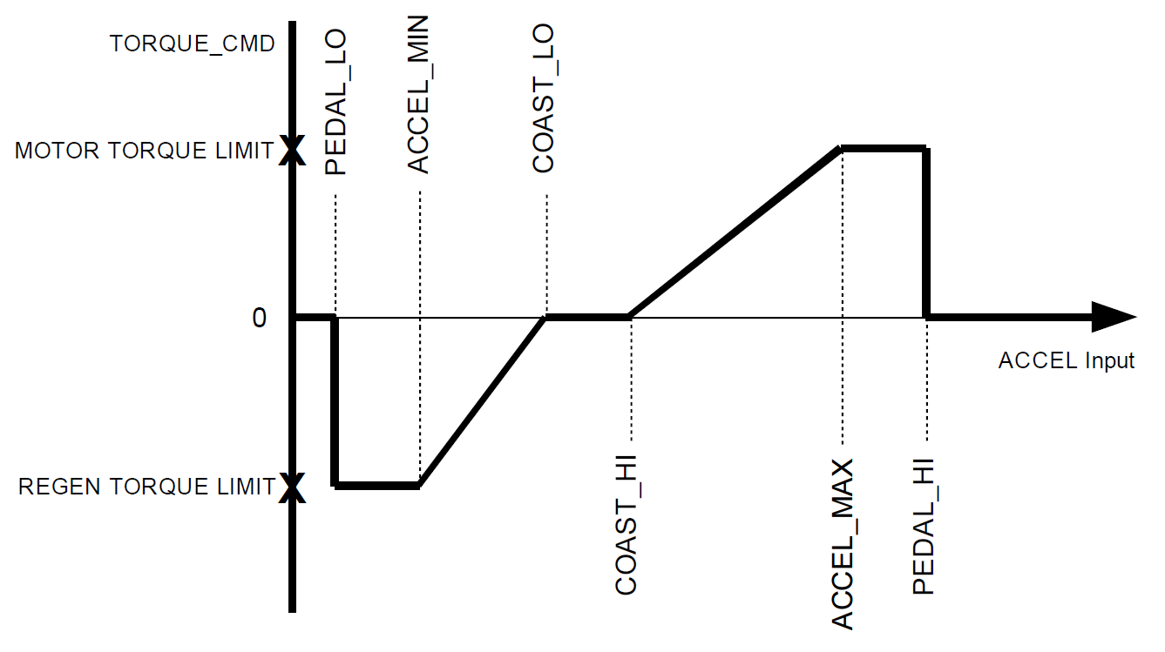

Figure 7‑2 Motor Controller troque input mapping

## Wiring

The wiring of the torque encoder is 18 AWG wire that connects to the plausibility system, and then to the motor controller. The internal voltage regulator in VCU provides 5V power for the throttle encoder. Simplified schematics is shown in Figure 7‑3.

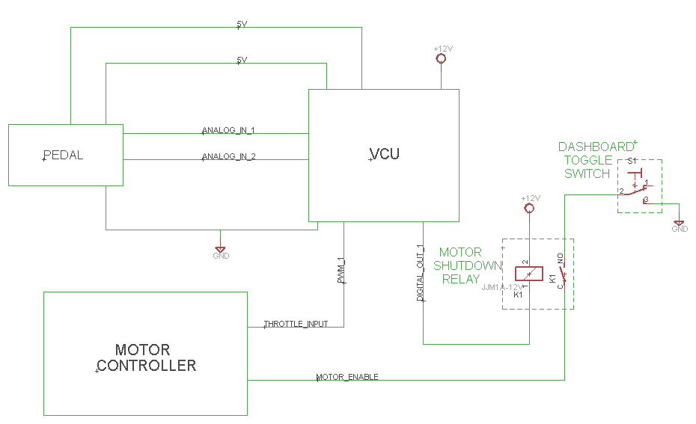

Figure 7‑3 Torque encoder wiring schematics (simplified)

## Position in car/mechanical fastening/mechanical connection

The torque encoder are hall-effect sensors located in an OEM accelerator assembly. The assembly is bolted to a 40 degree angled mount, which is bolted to the pedal box, as shown in Figure 7‑4.

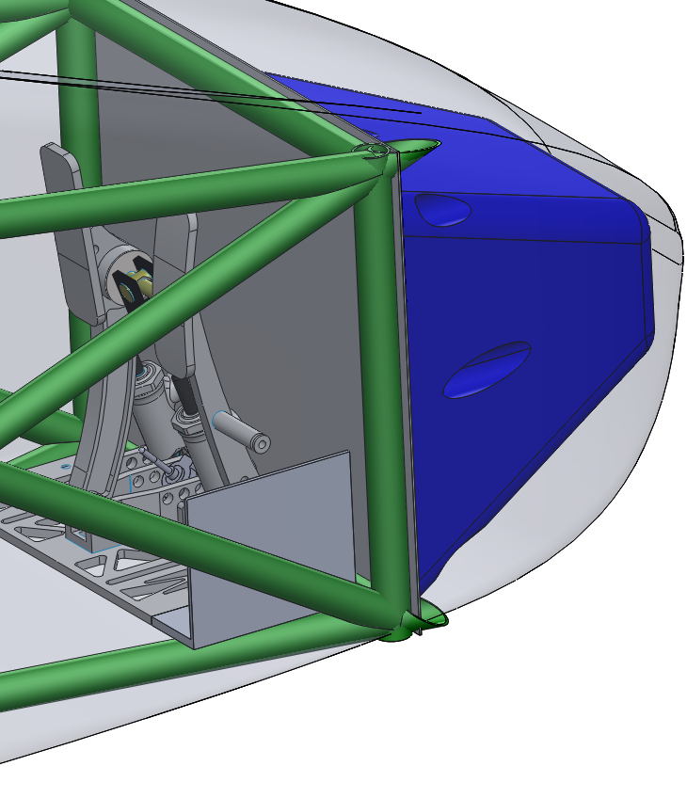

Figure 7‑4 Location of the pedal assembly

# Additional LV-parts interfering with the tractive system

## LV part 1

Describe those parts here which interfere or influence the tractive system, for example a controlling unit that measures wheel speeds and steering angle and calculates a target torque for each motor or a DC/DC-Converter providing power for the LV-system from the HV-system, etc.

### Description

Describe the parts used and their circuitry, and provide main operation parameters, use tables or figures, etc.

### Wiring, cables,

Describe the wiring, show schematics, etc.

### Position in car

Provide CAD-renderings showing the relevant parts. Mark the parts in the rendering, if necessary.

## LV part 2

…

# Overall Grounding Concept

## Description of the Grounding Concept

The chassis of the car will be used as the common ground for the low voltage system. The chassis is made of steel, and will have additional connections to keep the resistance to common ground below the required 300 mOhms. This includes areas of the chassis within 100mm of the tractive system. Other components of the vehicle that may become conductive will have measures taken to ensure <5 Ohms resistance to common ground.

## Grounding Measurements

The 12V battery that supplies the GLVS is located in the LV component area below the driver’s seat. Measurements will be taken in several locations to ensure grounding requirements are met, and extra grounding straps added to keep resistance below 300 mOhms.  The fiberglass body is not within 100 mm of any HV component. Also fiberglass can’t possibly become conductive.

# Firewall(s)

## Firewall 1

### Description/materials

A 1/16” FR4 sheet with Aluminum on the motor side behind the seat is used as the firewall. The tractive side is 0.6 mm thick Aluminium. This material meets the required scratch and puncture resistance of the UL94-V0 standards.

### Position in car

The firewall placement is shown in Figure 10‑1

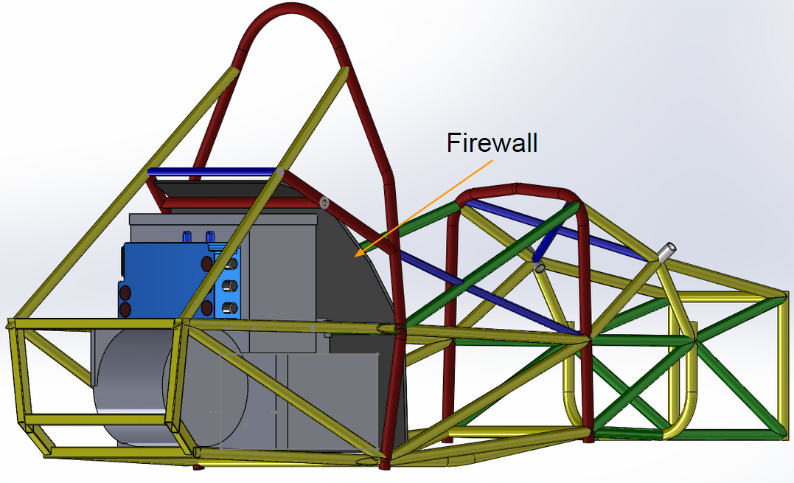

Figure 10‑1 Position of rear firewall

# Appendix

**Numbering according to chapter 1 to 10**

A datasheet for motor controller one for example has to have the numbering 11.10.5

Example appendix entry:

11.2.2 – Bender IR155-3203 IMD ratings

Referred from 2.1.1.

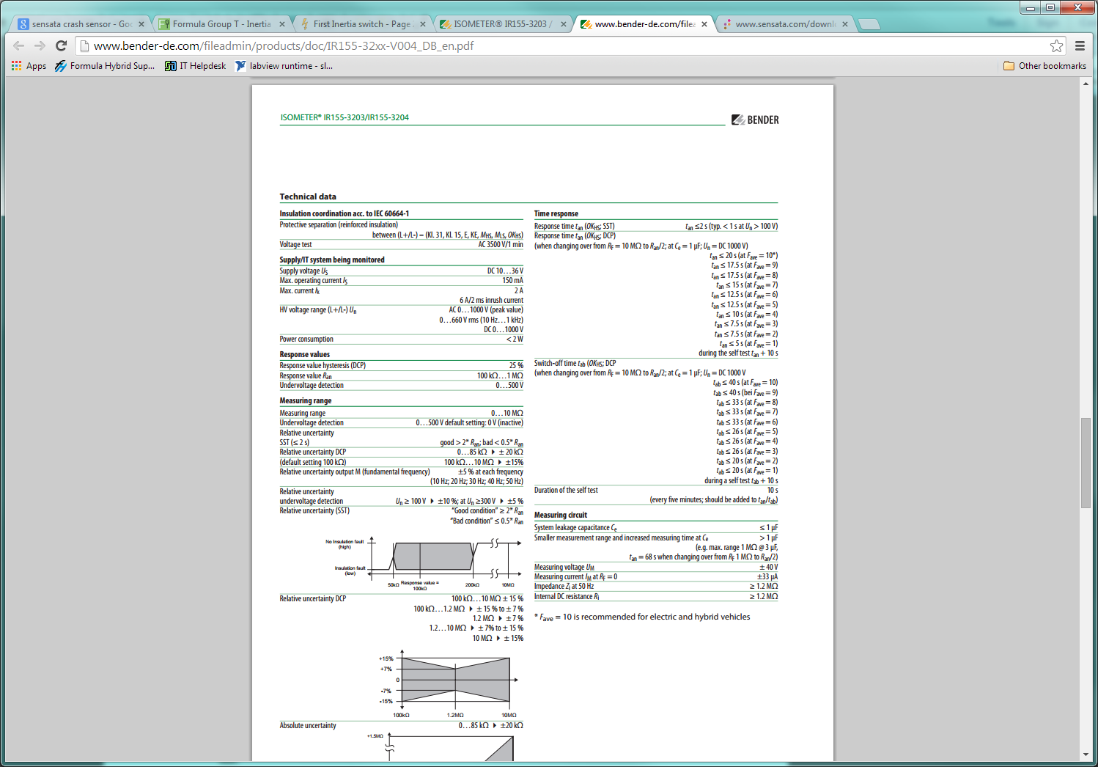

Complete data sheet located at: <http://www.bender-de.com/fileadmin/products/doc/IR155-32xx-V004_DB_en.pdf>